Project Two Final Database Report – by Olivia C. Smith

Developer’s Note
This ERD is likely far from perfect, but it is what I’ve come up with so far and I believe it is at the very least a good starting point. Please feel free to ask questions about the structure of the database or any concerns related to it.
By no means am I an expert in databases and I still believe there are many improvements that could have been made to this database, but it will work for the purpose of this project. Over time, I would like to make such improvements, but for now this is where the database stands.

Entity Relational Diagram

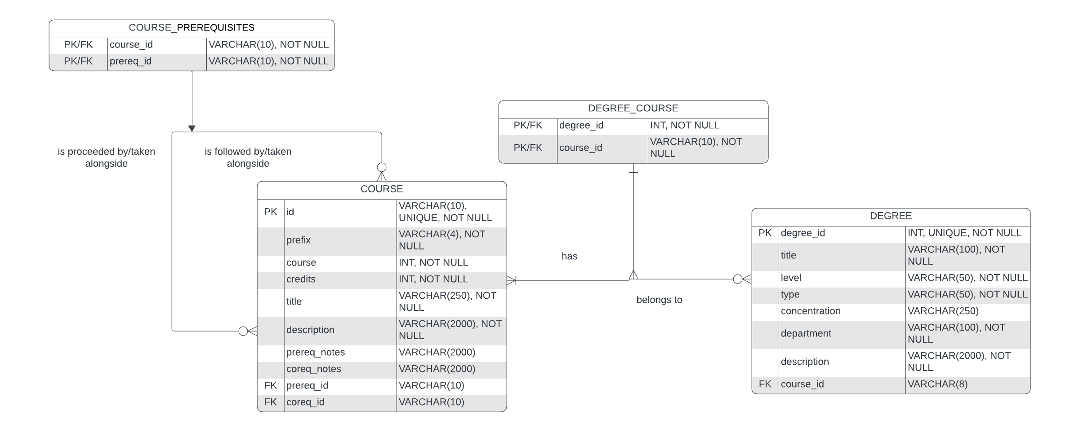

Structure Assumptions

- A COURSE can have zero to many prerequisite COURSES
- A prerequisite COURSE can proceed zero to many COURSES
- A DEGREE can have one to many COURES
- A COURSE can belong to zero to many DEGREES

Structure Notes

Regarding COURSE
A self-referencing many-to-many relationship is used with the course table to account for prerequisite courses. As a course can have no or multiple prerequisites, it can also account for any of those situations. As with any many-to-many relationship, it includes an associative entity, COURSE_PREREQUISITIES
The foreign keys on the course table are not tagged with “NOT NULL” due to some courses not having any prerequisites or corequisites. Therefore, this is optional and a key reason why on both ends of the relationship it is defined as zero-to-many.

Regarding DEGREE
A many-to-many relationship is used connect the degree table to the course table. As a degree would (clearly) require at least one course to any number of courses, it is one-to-many. The same is true for relating course back to degree, as a course can be associated with any degree, however it is not a hard requirement. Therefore, on that side it is zero-to-many. Like with course, it has an associative entity, DEGREE_COURSE.

A Note on Corequisites Courses
Corequisites courses are courses that must be taken at the same time as another course and are similar to CSCI-1100 lecture and its associated lab course. While they exist within our school, they are rather uncommon. However, the self-referencing many-to-many relationship for the course table will handle them the same as prerequisites are handling and there should be little problem with it. In the event that there is a problem due to corequisite entries, it is likely that they can be omitted.

Notes on Changes and Other Omitted Data

This database was intended to be CBAT only, however a few extra non-CBAT courses had to be added to account for certain course requisites. Examples of these were ARTH and MATH courses for Digital Media and Computer Science majors.
There are several higher-level courses throughout the CBAT catalog that have a range of credit hours associated with them. For the purposes of this project, the highest amount of credit hours possible for a course were used in the database to avoid issues. For example, CSCI-4900 has a credit hour range of 1 to 9, but in the database, it will simply be 9 credit hours.
A big issue encountered making this database was the concept of certain degrees having “sub-concentrations” or pathways. This is defined as two or more groups of courses that can be taken to earn a degree. For the purposes of this project, courses in pathways will not be associated with their respective degrees, however the courses are still in the database and can still be viewed. With this issue, there are many courses in the database that are not related to a degree. This is not an issue; however, I strongly recommend viewing the official ETSU website on more information regarding pathways within degrees. The following degrees have either sub-concentrations or have several options on what courses a student can take:
- Economics – General
- Management – General
- Marketing – Entrepreneurship
- Marketing – Integrated
- Digital Media – Animation
- Digital Media – Game Design
- Digital Media – Visual Effects
- Digital Media – Visualization
- Media and Communication, B.A.
- Media and Communication, B.S.

As stated before, there are no universal general education courses included in this database. with a few exceptions as stated above. That said, this is only accounting for undergraduate courses and degrees.

